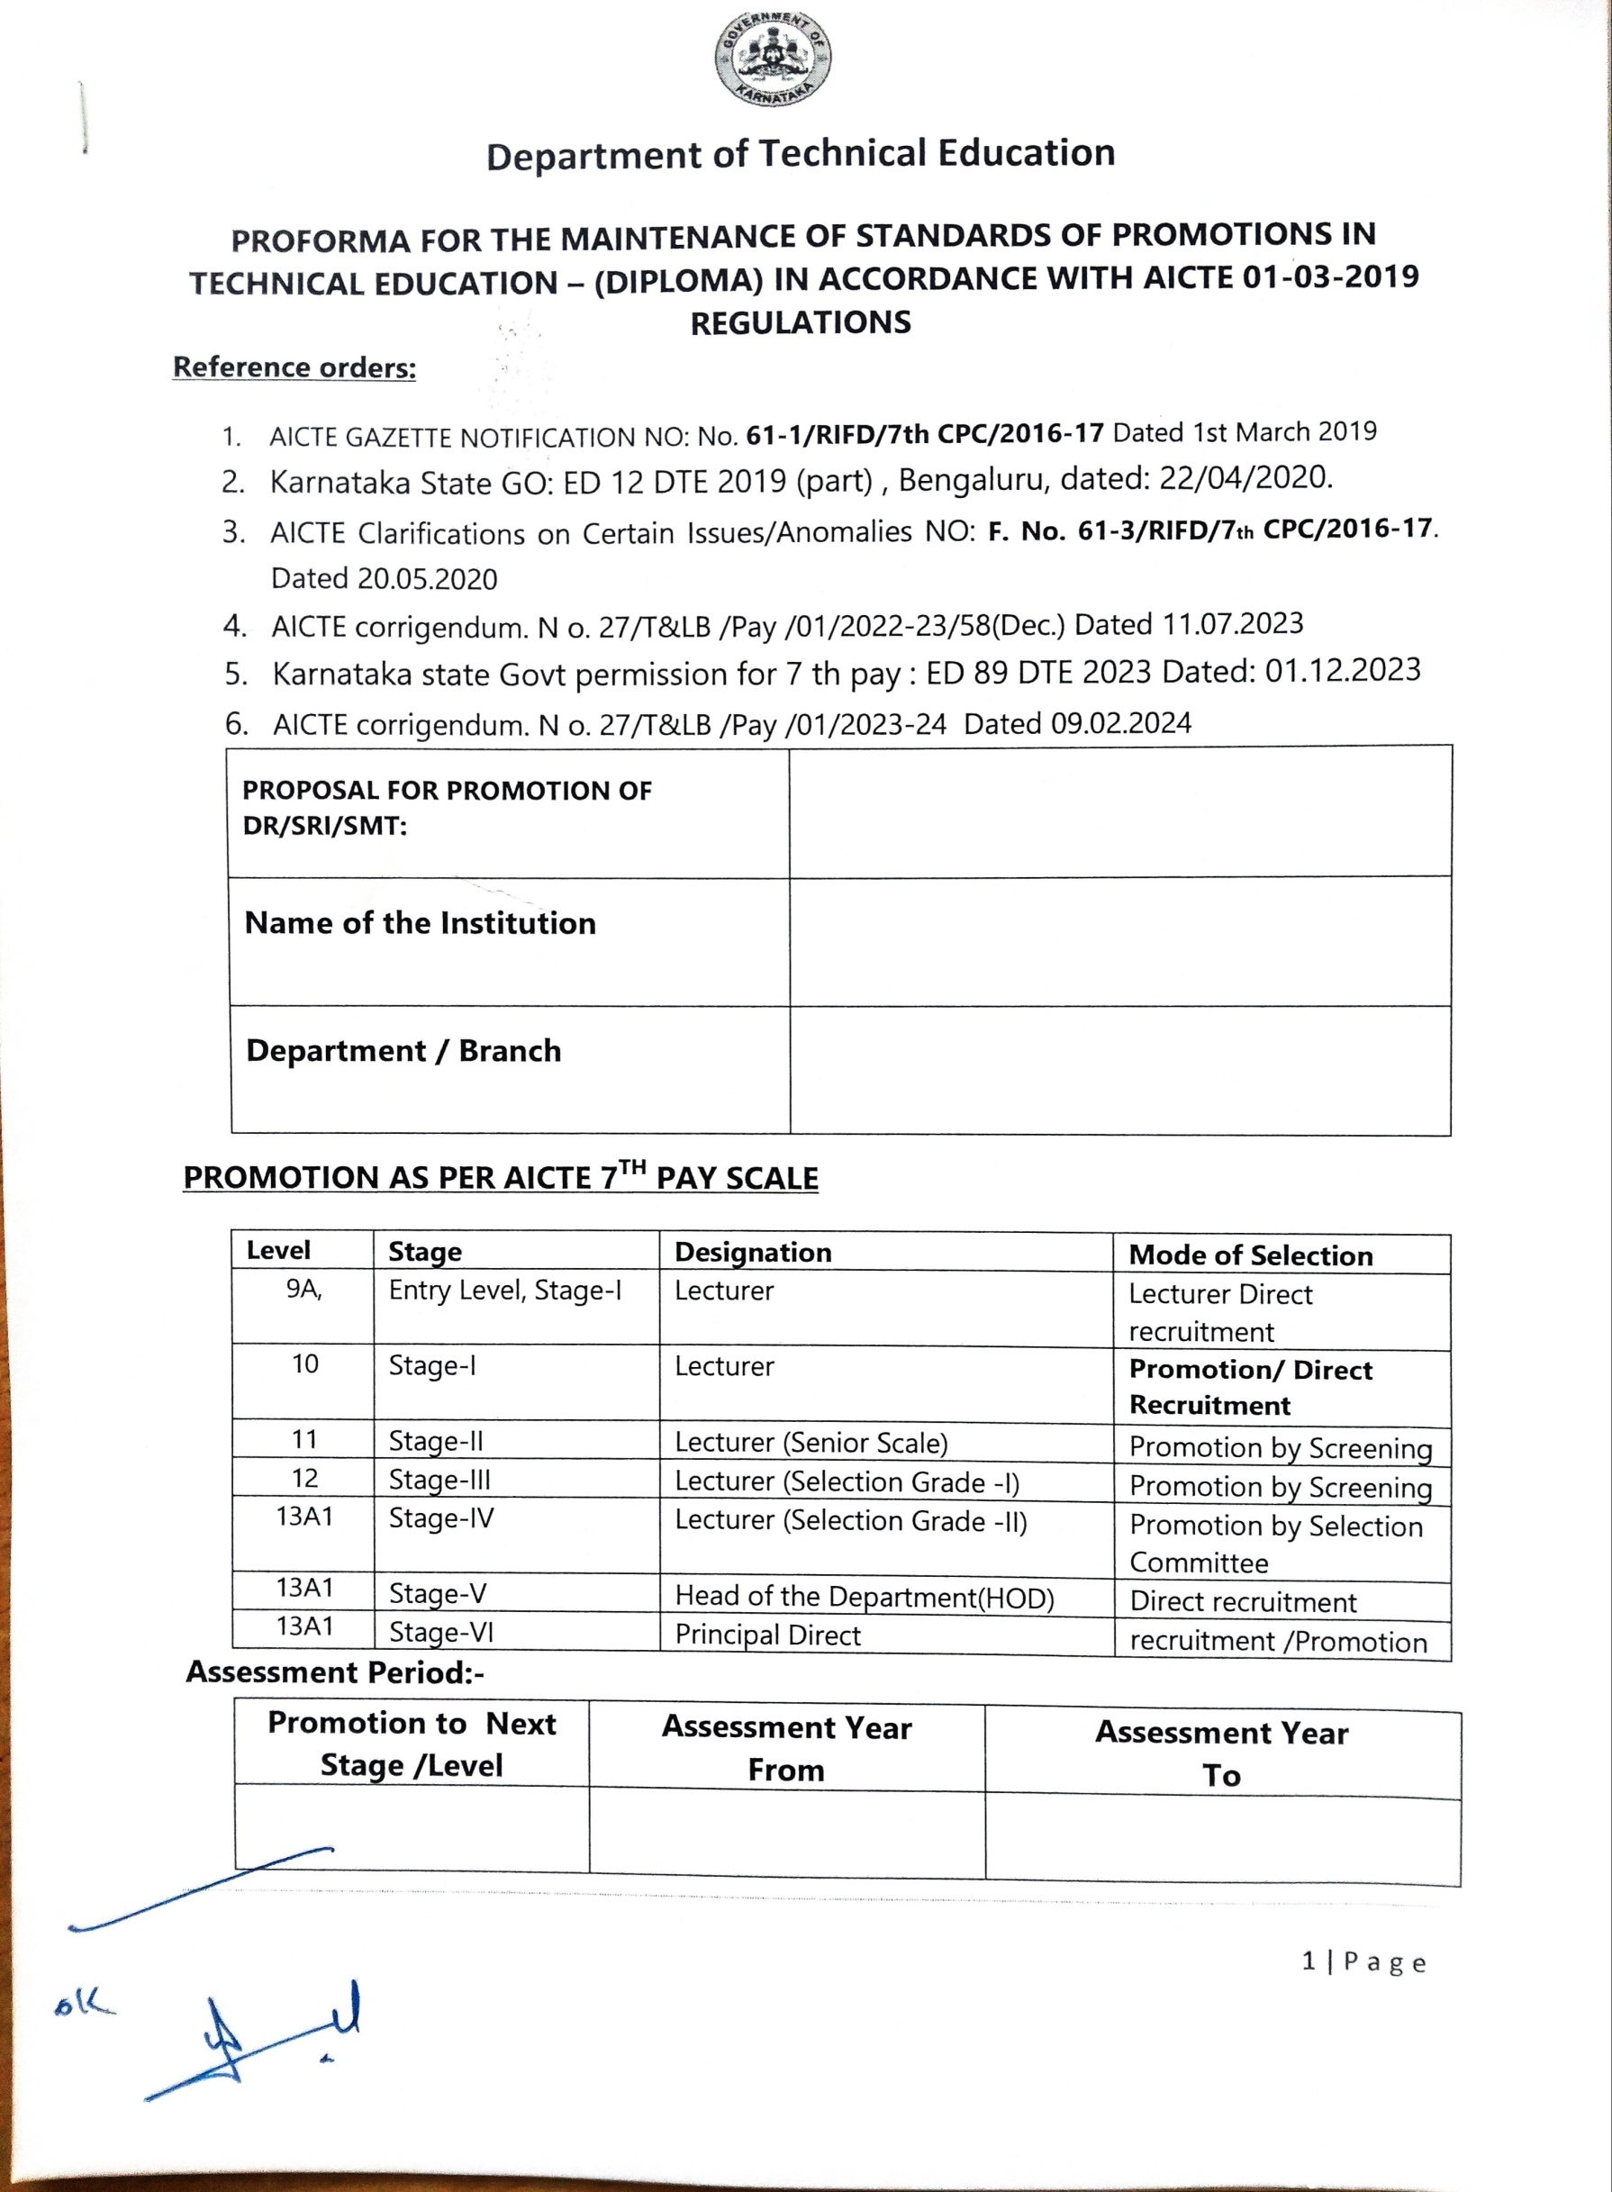

ScannedwithACEScanner



## DepartmentofTechnicalEducation

##### PROFORMA FOR THE MAINTENANCE OF STANDARDS OF PROMOTIONS IN TECHNICAL EDUCATION–(DIPLOMA) IN ACCORDANCEWITHAICTE 01-03-2019 REGULATIONS

**Reference orders:**

1. AICTE GAZETTE NOTIFICATION NO:No.**61-1/RIFD/7thCPC/2016-17**Dated1stMarch2019
2. KarnatakaStateGO:ED12DTE2019(part), Bengaluru,dated:22/04/2020.
3. AICTE Clarifications on Certain Issues/AnomaliesNO: **F.No.61-3/RIFD/7thCPC/2016-17**.

Dated20.05.2020

1. AICTEcorrigendum.No.27/T&LB/Pay/01/2022-23/58(Dec.)Dated11.07.2023
2. Karnataka state Govt permission for7th pay: ED89DTE2023Dated: 01.12.2023
3. AICTE corrigendum.No.27/T&LB/Pay/01/2023-24Dated09.02.2024

|  |  |
| --- | --- |
| **PROPOSAL FOR PROMOTION OF DR/SRI/SMT:** | **Smt. MALATI B SAJJAN** |
| **Name of the Institution** | **Government Polytechnic Zalaki** |
| **Department/Branch** | **Computer science and engg** |

##### PROMOTIONASPERAICTE7THPAY SCALE

|  |  |  |  |
| --- | --- | --- | --- |
| **Level** | **Stage** | **Designation** | **Modeof Selection** |
| 9A, | EntryLevel,Stage-I | Lecturer | LecturerDirect recruitment |
| 10 | Stage-I | Lecturer | **Promotion/Direct Recruitment** |
| 11 | Stage-II | Lecturer(SeniorScale) | PromotionbyScreening |
| 12 | Stage-III | Lecturer(SelectionGrade-I) | PromotionbyScreening |
| 13A1 | Stage-IV | Lecturer(SelectionGrade-II) | PromotionbySelection Committee |
| 13A1 | Stage-V | HeadoftheDepartment(HOD) | Directrecruitment |
| 13A1 | Stage-VI | PrincipalDirect | recruitment/Promotion |

**Assessment Period:**

|  |  |  |
| --- | --- | --- |
| **Promotion to Next Stage / Level** | **Assessment Year From** | **Assessment Year To** |
| Stage-III/ Level 12 Lecturer(Selection Grade-I) | 11-3-2017 | 11-03-2022 |

#### **PARTA: GENERAL INFORMATION AND ACADEMIC BACKGROUND**

|  |  |  |
| --- | --- | --- |
| 01 | Name of the faculty & KGIDNO | SMT.MALATI. B. SAJJAN  222-2512 |
| 02 | Name Of the Department | COMPUTER SCIENCE AND ENGG. **ENGG** |
| 03 | Name Of The Institution | GOVERNMENT POLYTECHNIC ZALAKI |
| 04 | Date of Joining  (Copy of appointment letter should be enclosed) | 11-3-2008 |
| 05 | Date of Probationary Declared(order copy) | 11-3-2010 |
| 06 | Entry Qualification(Certificate enclosed) | BE |
| 07 | Departmental permission letter for Higher education  (Any Master’s degree/Ph.D) Order copy |  |
| 08 | Acquired Qualification in Service:  If any(Certificate enclose) | MTech |
| 09 | Indicate Category: SC/ST/OBC/Minority/Women  /Differently-abled categories/General category | OBC |
| 10 | Any Departmental enquiry/  Court case pending against the official | No |
| 11 | Previous AGP sanctioned order copy | **Yes (Yes/No)** |
| 12 | Date of Eligibility of Promotion | 17.01.2017 |
| 13 | CLT Passed | Yes |
| 14 | Date of Screening/Evaluation Meeting |  |
| 15 | All the documents and criteria verified as per the instructions Sheet |  |
| 16 | Recommendations | **(Yes/No)** |
| 17 | If not Recommended, Remarks |  |
| 18 | Phone numbers (Off./Res./Mob)and email Id |  |

Name and Signature

**Academic Qualifications (Engineering)**

|  |  |  |  |  |  |
| --- | --- | --- | --- | --- | --- |
| **Qualification** | **University/Board** | **Year of Passing** | **% of marks obtained** | **Division/ Class/Grade** | **Subjects/ Specialization** |
| B.E./B.Tech | VTU, Belgaum | 2005 | 69% | FC | B.E (CSE) |
| M.E/M.Tech | VTU, Belgaum | 2017 | 71.70% | FCD | M.Tech (CSE) |
| Ph.D.  (Relevant discipline) | NA | NA | NA | NA | NA |

**Academic Qualifications (Basic Science and Humanities) as per UGC REGULATION**

|  |  |  |  |  |  |
| --- | --- | --- | --- | --- | --- |
| **Qualification** | **University/Board** | **Year of Passing** | **% of marks**  **obtained** | **Division/ Class/**  **Grade** | **Subjects/ Specialization** |
| B.Sc/B.Com/B.A | NA | NA | NA | NA | NA |
| M.Sc/M.Com/M.A | NA | NA | NA | NA | NA |
| Others  (M.Phil.,etc) | NA | NA | NA | NA | NA |
| Ph.D | NA | NA | NA | NA | NA |
| UGC or CSIR,NET/SLET/SET qualified details( year of passing/date, register no/roll no) | | | | | |
| Year of passing/qualifying: | | Register/Roll No: | | | |

**Service details/Experience (from entry into service to till date)**

|  |  |  |  |  |  |
| --- | --- | --- | --- | --- | --- |
| **Sl. No** | **Institution and place** | **Designation** | **Pay Scale** | **From** | **To** |
| **1** | Govt .Polytechnic, Bijapur | Lecturer | 8000-13500 | 11-02-2008 | 30-03-2011 |
| **2** | Govt .Polytechnic, Bijapur | Lecturer | 15600-39100+5400AGP | 01-04-2011 | 10-02-2014 |
| **3** | Govt .Polytechnic, Bijapur | Lecturer | 15600-39100+6000AGP | 11.02.2014 | 16-01-2017 |
| **4** | G0vt.Polytechnic,Zalaki | Lecturer (Sr.Scale) | 15600-39100+7000AGP | 17-02-2017 | 16-02-2019 |
| **5** | G0vt.Polytechnic,Zalaki | Lecturer (Sr.Scale) | 68900-211500 | 17-02-2019 | Till Date |

**Research Experience:-**

|  |  |  |  |  |
| --- | --- | --- | --- | --- |
| **Institution/University** | **Department** | **Field of Specialization** | **Period** | |
| **From** | **To** |
| NIL | NIL | NIL | NIL | NIL |

**Faculty Development Programme (FDP) recognized by AICTE/UGC/TEQIP/ NITTTR/ Pandit Madan Mohan Malviya National Mission on Teachers and Teaching (PMMMNMTT)**

|  |  |  |  |  |
| --- | --- | --- | --- | --- |
| Sl  No | Name of the FDP | Institution Name and  Place | Period andDuration  (FromDate-To Date) | Recognized By |
| 1 | Professional Ethics and Indian Constitution | GPT Vijayapura | 27-02-2017 to  08-03-2017(2 weeks) | CCTEK/DTE |
| 2 | Professional Practices and OBE/Accreditation | GPT Vijayapura | 22-01-2018 to  01-02-2018(2 weeks) | CCTEK/DTE |
| 3 | Authoring Tools in Multimedia | WPT Hubballi | 21-06-2018 to  25-06-2018(1 week) | CCTEK/DTE |
| 4 | Open Educational Resources(OER) | GPT Hubballi | 27-12-2018 to  31-12-2018 ( 1 week) | CCTEK/DTE |
| 5 | Transforming Learning Using ICT in Technical Education | GPT Hubballi | 31-05-2019 to 10-06-2019 (2 weeks) | CCTEK/DTE |
| 6 | Joomla | MCPT Vijayapura | 11-05-2020 to  15-05-2020 ( 1 Week) | IIT Bombay,  ICT,MHRD |
| 7 | Data Analytics with Python | NITTTR Chandigarh | 22-06-2020 to  26-02-2020 (1 week) | AICTE |
| 8 | Advanced Pedagogical Techniques | GPT Hosadurga | 27-07-2022 to  31-07-2022 ( 1 week) | CCTEK/DTE |

**\*Note:** Atleast one of the FDP shall be in advanced pedagogy for Promotion To Level 11

###### OR

(One week faculty development programme as above and one eight weeks duration MOOCS course with E-Certification by NPTEL-AICTE)

|  |  |  |  |  |
| --- | --- | --- | --- | --- |
| Sl  No | Course Name | One Eight week course  (From Date-To Date) | NPTEL-AICTE  Roll No: | Consolidated  Score |
|  | NIL |  |  |  |

###### OR

(Completed two such eight weeks duration MOOCS courses with E-Certification by NPTEL-AICTE).

|  |  |  |  |  |
| --- | --- | --- | --- | --- |
| Sl  No | Course Name | Two Eight-week Course  (From Date-To Date) | NPTEL-AICTE  Roll No: | Consolidated  Score |
|  | NIL |  |  |  |

**List of Publications Journals:-SCI journals/ UGC/AICTE/COA/PCI approved list of journals**

|  |  |  |  |  |  |
| --- | --- | --- | --- | --- | --- |
| **Sl. No** | **Title of Paper** | **Name of Journal** | **Publisher name/ISSN NO:** | **Date of Publication and Impact**  **Factor if any** | **Volume number and Pages** |
| 1 | Enhanced Technique to Detect Glaucoma | IJRAR | IJRAR/ 2349-5138 | 27.09.2016/ 7.17 | Vol 3/Issue 3  Pg No 809-812 |

**INDUSTRIAL TRAINING (Three weeks)**

|  |  |  |  |  |
| --- | --- | --- | --- | --- |
| **Institute/Company** | **Duration (3-weeks)** | **From** | **To** | **Remarks** |
| Nandi Sahakari Sakkare Karkhane Niyamit, Krishanagar | 3 Weeks | 27.06.2022 | 16.07.2022 |  |

**Details of Deputation/OOD (with permission/approved by competent authority) (Department /Government)**

|  |  |  |  |  |  |
| --- | --- | --- | --- | --- | --- |
| **Sl No** | **ORGANISATION**  **/DEPT** | **Designation** | **Duration** | | **Remarks (if any)** |
| **From** | **To** |
|  | NIL |  |  |  |  |

**Declaration**

I am Smt. Malati B Sajjan working as Lecturer Senior Grade at Govt. Polytechnic Zalaki-176 hereby declare that the information provided above is true to the best of my knowledge. Any discrepancies found at any stage suitable action can be taken against me.

Place:-

Date:- **Name and Signature**